Marmara Üniversitesi Mühendislik Fakültesi
Elektrik-Elektronik Mühendisliği

Laboratory Manual EE 3011

Electronics I

Experiment (5)
Diode Rectifier with Peak Detector

Name | ID
Mehmet Ali Kamalak | 150720062

Spring 2025

Objectives
Experiment (1)
Diode Rectifier with Peak Detector

Page2
- To study the half-wave rectifier function.
- To analyze the output of a peak detector with regulator.

Pre-lab Work
Analyze the circuit below using the constant voltage diode model. The input is a sinusoidal wave with amplitude 𝑉! and frequency 𝑓. Find 𝑉" with and without the capacitor 𝐶. In each case, draw the waveform of the output and find the average output voltage and average load current.
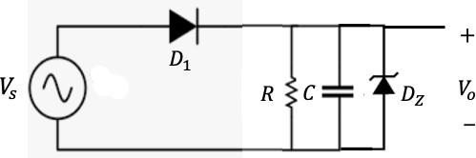
Solution

Figure 1: Half-wave rectifier with peak detector and regulator.

Equipment
Table 1. Equipment for experiment 5.

 | Equipment | Model | Serial No. | Stock No.
1 | BreadBoard Station
2 | 1 kΩ Resistor (2W, 5%)
3 | Capacitors (2)
4 | Diodes (2) | 1N4001 (1) 1N4732 (1)
5 | Multi-meter (1)
6 | Dual-trace Oscilloscope
7 | Probes and Cables

Experimental Procedure
Part (1): Half-wave Rectifier Output Analysis.
- Connect the circuit in figure 1 without the capacitor and the Zener diode and with 𝑅=1 kΩ. Pay aspecial attentiontohowyou connect the terminals of thediode. Theinputvoltage source
𝑉# is sinusoidal.
- Connect channel 1 of the oscilloscope to 𝑉# and adjust it to 10 V amplitude at 60 Hz. Pay attention to the polarity of the oscilloscope connection. Sketch the input waveform in graph 1 labeling all important points in both voltage and time axes. Make your sketch as accurate as possible.

- Now connect channel 2 of the oscilloscope to 𝑉0. Sketch the output waveform on the same graph 1 labeling all important points in both voltage and time axes. Make your sketch as accurate as possible. Use different colors for the waveforms.
- Using the multi-meter, measure the output voltage and record it in table 2.
Part (2): Half-wave Rectifier with Peak Detector and Regulator.
- Consider again the circuit in figure 1 with the capacitor connected only.
- Repeat the whole procedure in part 1 for both capacitors provided. Record results in graphs 1 and 2 and table 3. Use different colors for the waveforms.
- Finally, connect the Zener diode across the capacitor and observe the output. Record results in graphs 1 and 2. Use different colors for the waveforms.

Results and Analysis
Part (1): Half-wave Rectifier Output Analysis.

Graph 1: Sinusoidal input case.

Table 2. Average output voltage of the half-wave rectifier without peak detector.




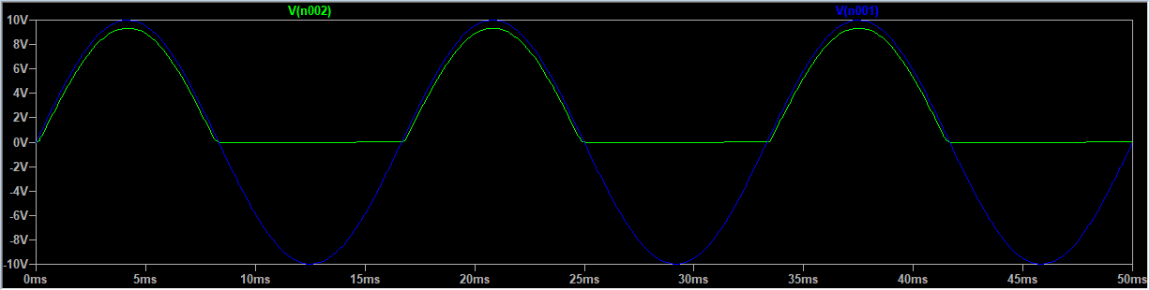
Page3
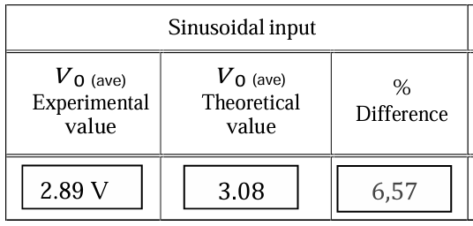

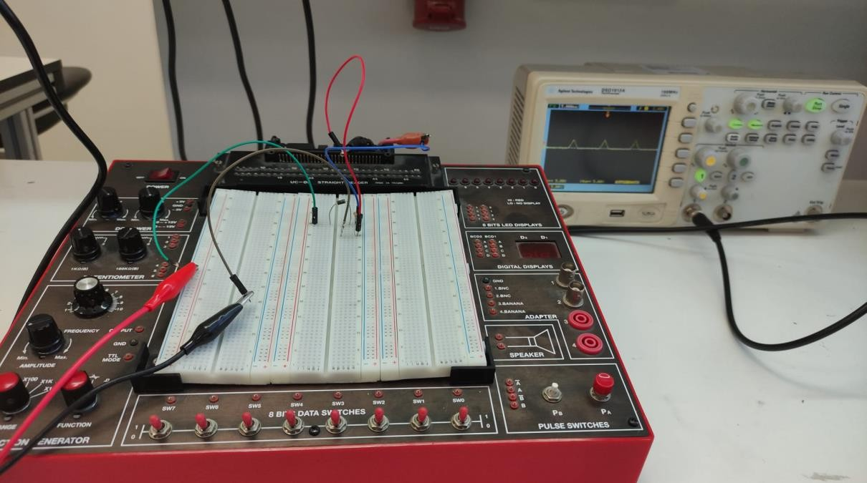
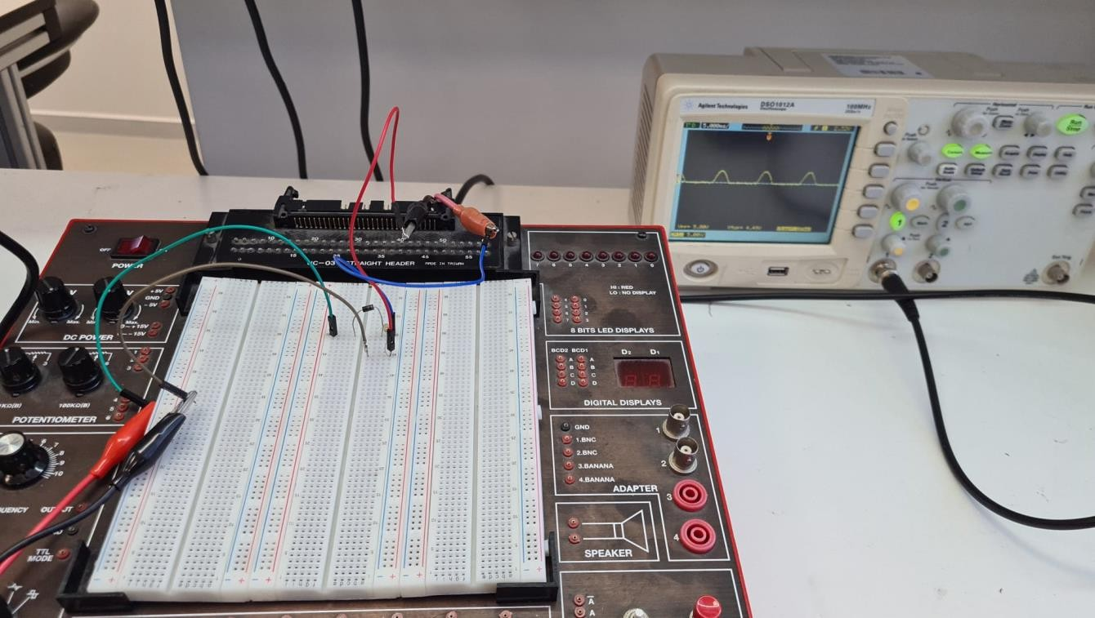
Page4
Laboratory Pictures
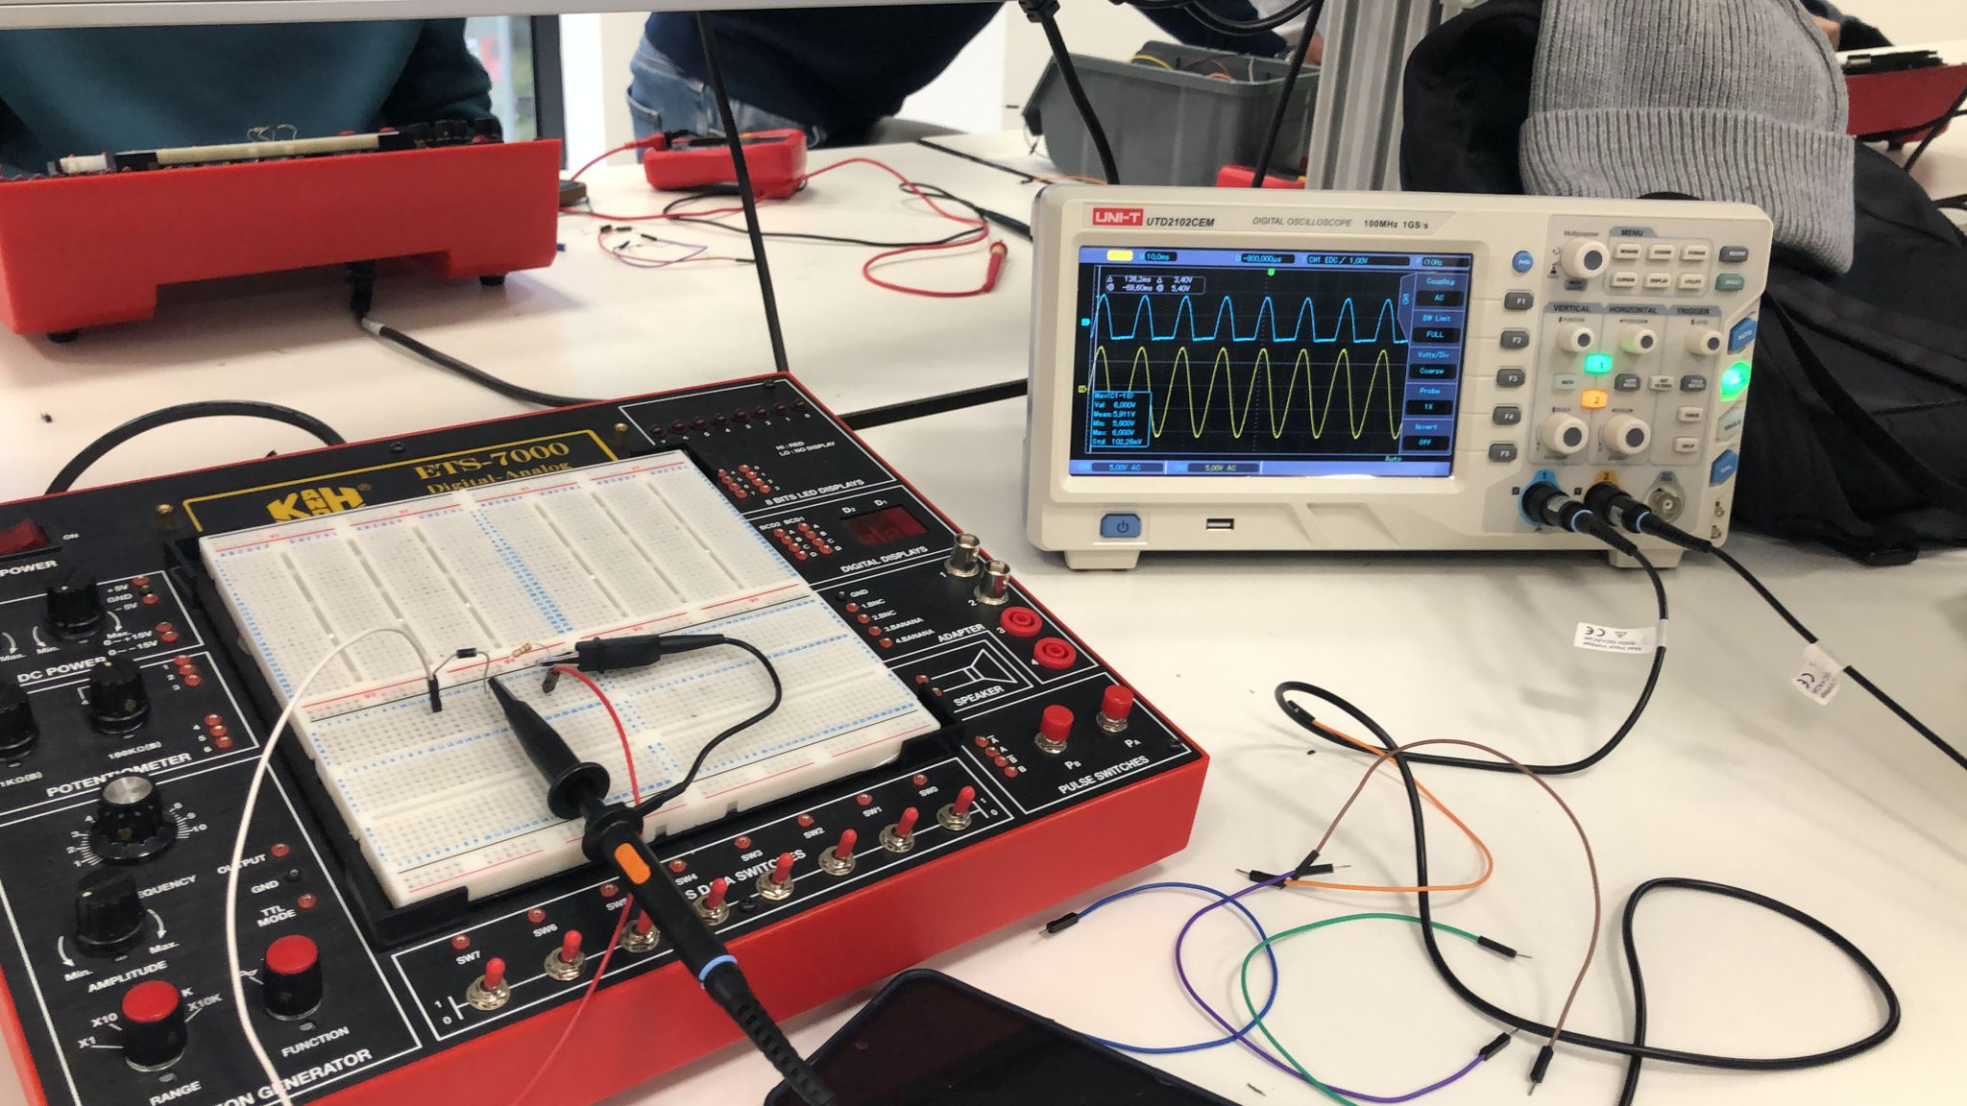

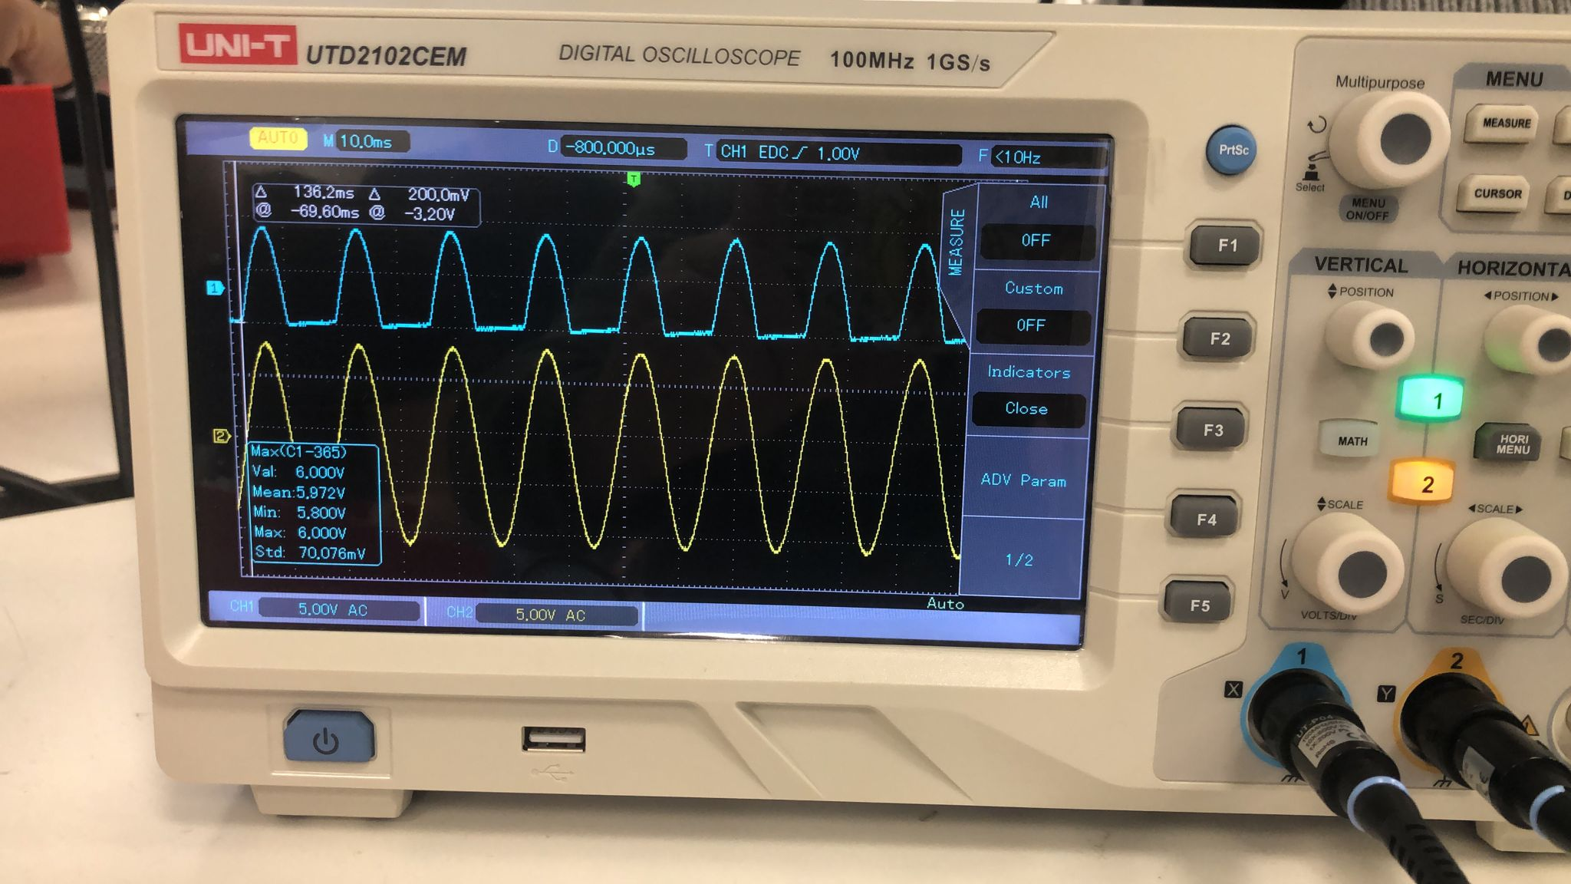

Sinusoidal Waveform Input
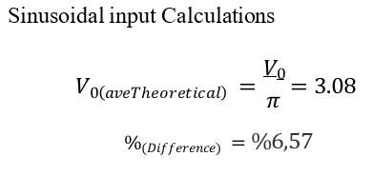

Page5


- Comment on your results regarding the waveforms in graphs 1 and 2.
The waveform observed in this experiment is sinusoidal, which is characterized by its smooth and continuous shape. Unlike other waveform types, sinusoidal signals have a continuously varying voltage amplitude that follows a sine function over time. This type of waveform is fundamental in electrical and electronic systems due to its predictable and periodic nature.

- Comment on your results regarding the average output voltage.
The average output voltage of a sinusoidal waveform is determined by its RMS voltage, which reflects the effective value of the waveform over time. Since the sinusoidal waveform varies smoothly and symmetrically around zero, the RMS value provides a useful measure of its average power-delivering capability in AC circuits.

Part (2): Half-wave Rectifier with Peak Detector and Regulator.

Table 3. Average output voltage of the half-wave rectifier with peak detector.

 |  | Sinusoidal input
 | Capacitor value (µF) | 𝑉0(ave) Experimental value | 𝑉0(ave) Theoretical value | %  Difference
Without Zener Diode | 47 | 7.6V | 6.717 V | 11.62
With Zener Diode | 47 | 7.3 V | 7.63 V | 0.5

Comment on your results regarding the waveforms in graphs 1 and 2.
In a half-wave rectifier circuit with a sinusoidal input waveform, the output voltage waveform is a smooth, pulsating DC signal. After passing through a filter capacitor, the output becomes more stable, with a small voltage ripple. This ripple occurs because the capacitor is charged during the positive half-cycles of the sinusoidal input and discharged between cycles when the input voltage drops below the capacitor voltage. The smooth variation of the sinusoidal input allows the capacitor to charge and discharge gradually, helping to minimize the ripple in the output voltage.

Comment on your results regarding the average output voltage
The output voltage is regulated by the combination of the capacitor and the Zener diode, which helps maintain a relatively constant voltage level. However, there is still a small voltage ripple present due to the charging and discharging cycles of the capacitor. In our experiment, we used a 47μF capacitor, and the voltage ripple can be observed from the output waveform graph and the related calculations. To further reduce the voltage ripple and achieve a smoother output voltage, the capacitance value can be increased, allowing the capacitor to store more charge and maintain a steadier voltage during the discharging phase.
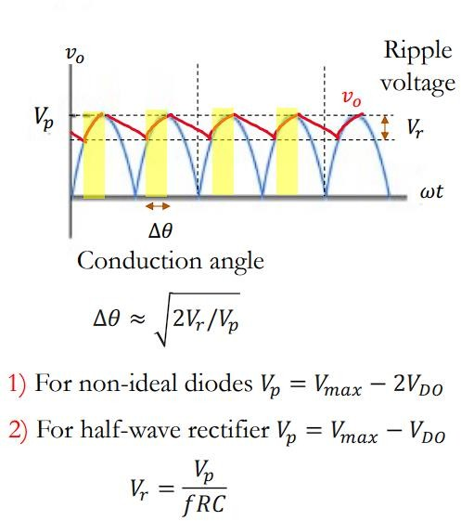
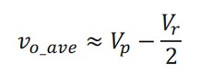
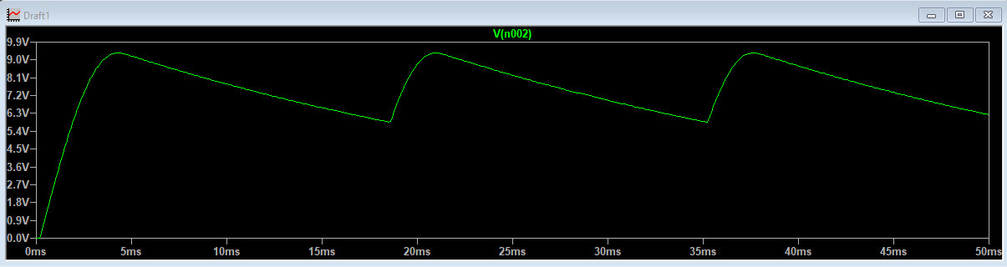
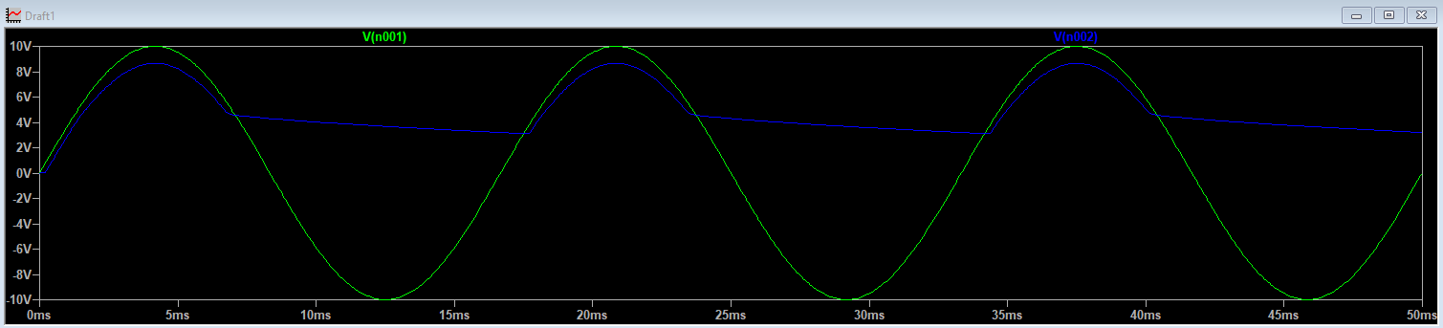
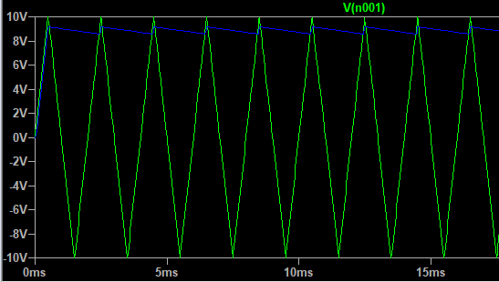
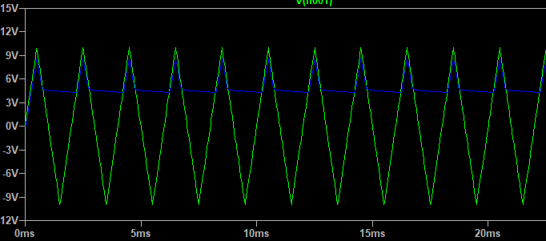
Page7

Without Zener Diode (Sinusoidal Wave)

With Zener Diode (Sinusoidal Wave)

Without Zener Diode With Zener Diode (Sinusoidal Wave)
CALCULATIONS
9,3
𝑉𝑟 = 60 ∗ 1000 ∗ 47 ∗ 10⁻⁶ = 5.166𝑉
𝑉𝑟
𝑉0(𝑎𝑣𝑒𝑇ℎ𝑒𝑜𝑟𝑒𝑡𝑖𝑐𝑎𝑙) = 𝑉𝑝 − 2 = 6.717
𝑉𝑟
𝑉0(𝑎𝑣𝑒𝐸𝑥𝑝𝑒𝑟𝑖𝑚𝑒𝑛𝑡𝑎𝑙) = 𝑉𝑝 − 2 = 7.6
%(𝑑𝑖𝑓𝑓𝑒𝑟𝑒𝑛𝑐𝑒) = 11.62

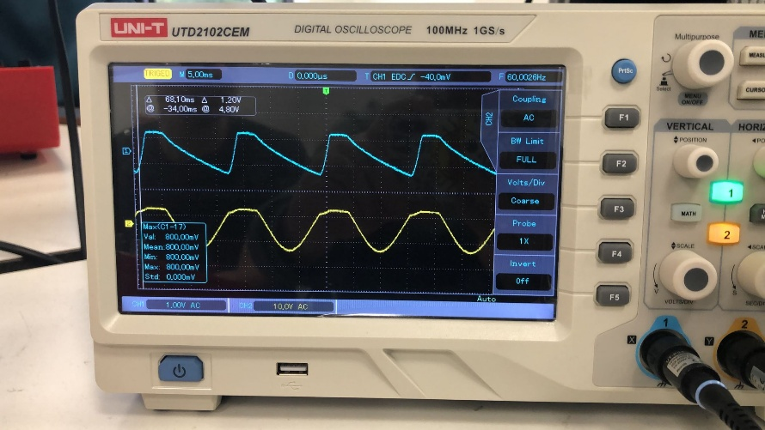
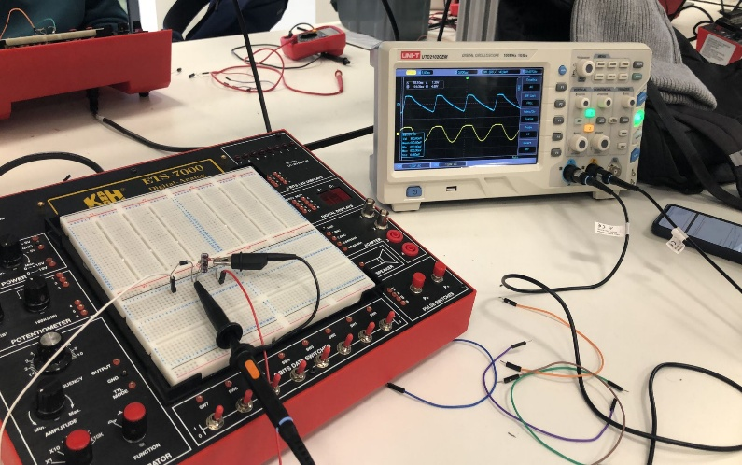

With Zener Diode (Sinusoidal Waveform)

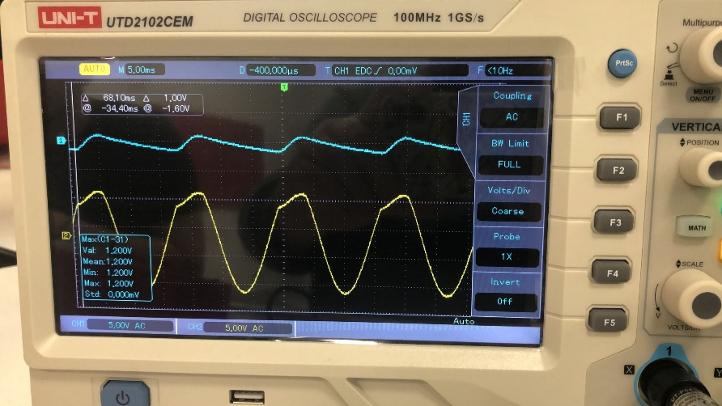
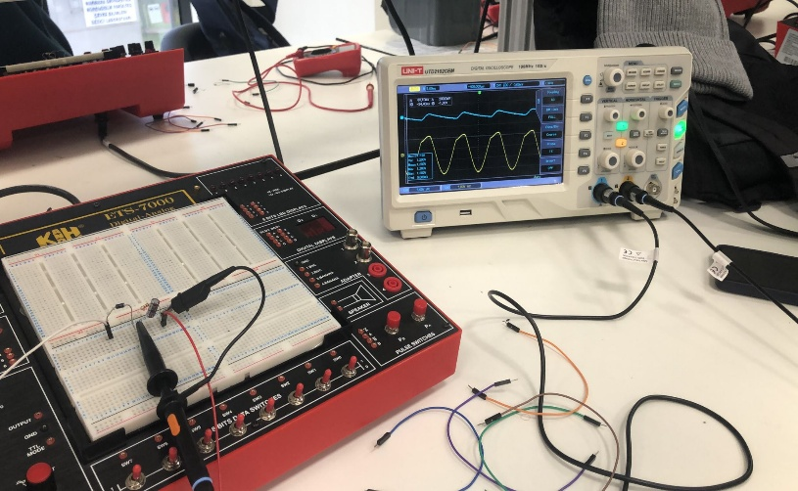

Without Zener Diode (Sinusoidal Waveform)

Page8
Conclusions

In this experiment, we have handled three different circuit configurations and observed their effects on the output waveform.

In the first configuration, an ideal diode (1N4001) is connected in series with a 1kΩ resistor. This setup acts as a half-wave rectifier, allowing only the positive half-cycles of the sinusoidal input waveform to pass, while blocking the negative half-cycles. As a result, the output voltage is lower than the input and consists only of the positive portions of the waveform.

In the second configuration, the same diode is connected in series with a parallel combination of a 1kΩ resistor and a 47 μF capacitor. This forms a filter circuit that smooths out the rectified waveform. The capacitor reduces the voltage ripple by storing charge during the positive cycles and releasing it between them, providing a more stable DC output.

In the third configuration, a Zener diode (1N4732) is added in parallel with the resistor and capacitor. This forms a regulated DC power supply. The Zener diode maintains a constant output voltage once the input exceeds its breakdown voltage. The proper Zener voltage rating and resistor value must be selected based on the desired output and current requirements.

In conclusion, as we add new components to the circuit, we observe different functionalities such as rectification, filtering, and regulation. At each stage, the circuit gradually converts the AC sinusoidal input to a more stable DC output.

